Child’s Name___________________________ Parent Signature _________________________________
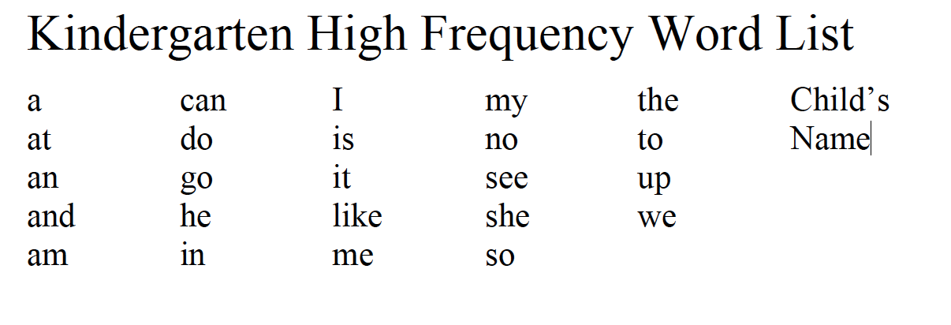
Grade | Kindergarten Blizzard Bag Day 2
Math | Gather a collection of 20 objects (can be coins, matchbox cars, blocks paperclips, etc.). Use the numeral cards 1-10 (from the day 1 blizzard bag or any numeral card deck is fine) and place them face down. Have your child turn over a card and make 3 collections – one that is the same as the numeral card, one that is more than the numeral card and one that is less the than numeral card.
Reading | Watch of the read aloud links on our webpage or read aloud to your child.  - With support and prompting orally retell story including key details, main character, and setting.  - Draw a picture of the setting in the text and write a sentence about where the story takes place.  Practice 25 high frequency words both reading and writing. (see below)
Writing | Write an informative/explanatory text using a combination of pictures and writing and dictating. Name your topic (what you are writing about) and tell some information about the topic.  (e.g., Topics: My dog Avery, How to build the best snowman)
Social Studies  (Optional) | Use a Calendar to review the concept of chronological time. Review categories of time such as long ago, yesterday, today and tomorrow.

